Lesson: Basic I/O
This lesson covers the Java platform classes used for basic I/O. It first focuses on I/O Streams, a powerful concept that greatly simplifies I/O operations. The lesson also looks at serialization, which lets a program write whole objects out to streams and read them back again. Then the lesson looks at file I/O and file system operations, including random access files. Finally, it touchs briefly on the advanced features of the New I/O API.
Most of the classes covered in the I/O Streams section are in the java.io package. Most of the classes covered in the File I/O section are in the java.nio.file package.

1) I/O Streams
An I/O Stream represents an input source or an output destination. A stream can represent many different kinds of sources and destinations, including disk files, devices, other programs, and memory arrays.
Streams support many different kinds of data, including simple bytes, primitive data types, localized characters, and objects. Some streams simply pass on data; others manipulate and transform the data in useful ways.
No matter how they work internally, all streams present the same simple model to programs that use them: A stream is a sequence of data. A program uses an input stream to read data from a source, one item at a time, A program uses an output stream to write data to a destination, one item at time:
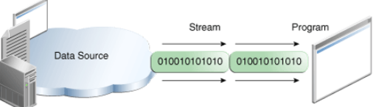
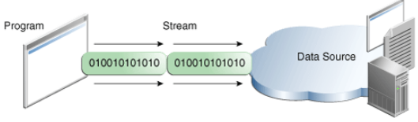

- In this lesson, we'll see streams that can handle all kinds of data, from primitive values to advanced objects.
The data source and data destination pictured above can be anything that holds, generates, or consumes data. Obviously this includes disk files, but a source or destination can also be another program, a peripheral device, a network socket, or an array.
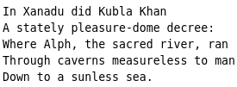
In the next section, we'll use the most basic kind of streams, byte streams, to demonstrate the common operations of Stream I/O. For sample input, we'll use the example file xanadu.txt, which contains the following verse:

Byte Streams
Programs use byte streams to perform input and output of 8-bit bytes. All byte stream classes are descended from InputStream and OutputStream.
There are many byte stream classes. To demonstrate how byte streams work, we'll focus on the file I/O byte streams, FileInputStream and FileOutputStream. Other kinds of byte streams are used in much the same way; they differ mainly in the way they are constructed.
There are many byte stream classes. To demonstrate how byte streams work, we'll focus on the file I/O byte streams, FileInputStream and FileOutputStream. Other kinds of byte streams are used in much the same way; they differ mainly in the way they are constructed.

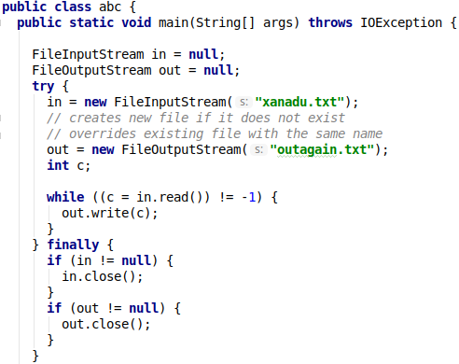
Using Byte Streams
We'll explore FileInputStream and FileOutputStream by examining an example program named CopyBytes, which uses byte streams to copy xanadu.txt, one byte at a time.
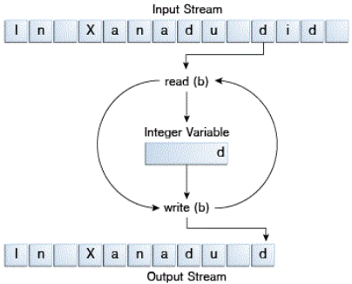
CopyBytes spends most of its time in a simple loop that reads the input stream and writes the output stream, one byte at a time, as shown in the following figure.

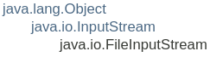
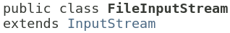

A FileInputStream obtains input bytes from a file in a file system. What files are available depends on the host environment.
FileInputStream is meant for reading streams of raw bytes such as image data. For reading streams of characters, consider using FileReader.

Constructor and Description
- FileInputStream(File file) Creates a FileInputStream by opening a connection to an actual file, the file named by the File object file in the file system.
- FileInputStream(FileDescriptor fdObj) Creates a FileInputStream by using the file descriptor fdObj, which represents an existing connection to an actual file in the file system.
- FileInputStream(String name) Creates a FileInputStream by opening a connection to an actual file, the file named by the path name name in the file system.
Method Summary read() için COUNTER NERDE? (native c code prob.)
int available() Returns an estimate of the number of remaining bytes that can be read (or skipped over) from this input stream without blocking by the next invocation of a method for this input stream.
void close() Closes this file input stream and releases any system resources associated with the stream.
protected void finalize() Ensures that the close method of this file input stream is called when there are no more references to it.
FileChannel getChannel() Returns the unique FileChannel object associated with this file input stream.
FileDescriptor getFD() Returns the FileDescriptor object that represents the connection to the actual file in the file system being used by this FileInputStream.
int read() Reads a byte of data from this input stream. Returns: the next byte of data, or -1 if the end of the file is reached.
int read(byte[] b) Reads up to b.length bytes of data from this input stream into an array of bytes.
int read(byte[] b, int off, int len) Reads up to len bytes of data from this input stream into an array of bytes.
long skip(long n) Skips over and discards n bytes of data from the input stream.
Ufak Tekrar: This article describes how supplementary characters are supported in the Java platform. Supplementary characters are characters in the Unicode standard whose code points are above U+FFFF, and which therefore cannot be described as single 16-bit entities such as the char data type in the Java programming language.
Basic Multilingual Plane: U+0000 – U+FFFF the others are called supplementary characters
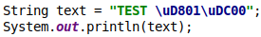
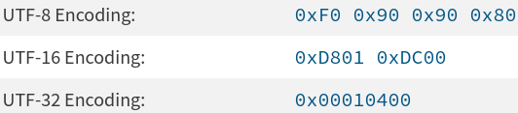
𐐀 : U+10400

Always Close Streams
Closing a stream when it's no longer needed is very important — so important that CopyBytes(benim programım) uses a finally block to guarantee that both streams will be closed even if an error occurs. This practice helps avoid serious resource leaks.
One possible error is that CopyBytes was unable to open one or both files. When that happens, the stream variable corresponding to the file never changes from its initial null value. That's why CopyBytes makes sure that each stream variable contains an object reference before invoking close.

When Not to Use Byte Streams
CopyBytes seems like a normal program, but it actually represents a kind of low-level I/O that you should avoid. Since xanadu.txt contains character data, the best approach is to use character streams, as discussed in the next section. There are also streams for more complicated data types. Byte streams should only be used for the most primitive I/O.
So why talk about byte streams? Because all other stream types are built on byte streams.

Character Streams
The Java platform stores character values using Unicode conventions. Character stream I/O automatically translates this internal format to and from the local character set. In Western locales, the local character set is usually an 8-bit superset of ASCII.
For most applications, I/O with character streams is no more complicated than I/O with byte streams.
Input and output done with stream classes automatically translates to and from the local character set. A program that uses character streams in place of byte streams automatically adapts to the local character set and is ready for internationalization — all without extra effort by the programmer. Benim burda anladığım: Java otomatik olarak senin local olarak kullandığın char seti tanıyıp uygun şekilde (alırken) unicode’a convert ediyor veya (yazarken) unicode’dan ASCII’ye convert ediyor (mesela linuxde baktığım birkaç txt dosyası ASCII idi)
If internationalization isn't a priority, you can simply use the character stream classes without paying much attention to character set issues. Later, if internationalization becomes a priority, your program can be adapted without extensive recoding. See the Internationalization trail for more information.

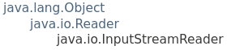
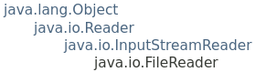
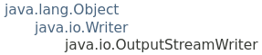
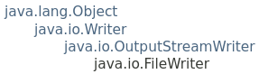
Using Character Streams
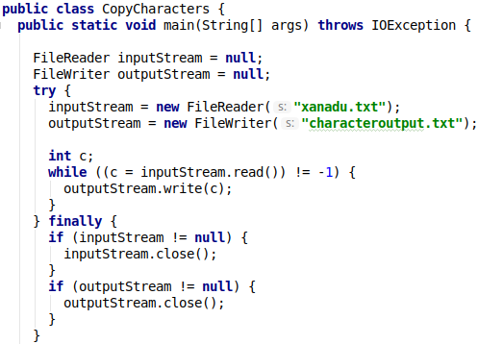
All character stream classes are descended from Reader and Writer (Both are abstract classes). As with byte streams, there are character stream classes that specialize in file I/O: FileReader and FileWriter. The CopyCharacters example illustrates these classes.
CopyCharacters is very similar to CopyBytes. The most important difference is that CopyCharacters uses FileReader and FileWriter for input and output in place of FileInputStream and FileOutputStream. Notice that both CopyBytes and CopyCharacters use an int variable to read to and write from. However, in CopyCharacters, the int variable holds a character value in its last 16 bits; in CopyBytes, the int variable holds a byte value in its last 8 bits (the first 24 bits are ignored).

Character Streams that Use Byte Streams
Character streams are often "wrappers" for byte streams. The character stream uses the byte stream to perform the physical I/O, while the character stream handles translation between characters and bytes. FileReader, for example, uses FileInputStream, while FileWriter uses FileOutputStream.
There are two general-purpose byte-to-character "bridge" streams: InputStreamReader and OutputStreamWriter. Use them to create character streams when there are no prepackaged character stream classes that meet your needs. The sockets lesson in the networking trail shows how to create character streams from the byte streams provided by socket classes.

Line-Oriented I/O
Character I/O usually occurs in bigger units than single characters. One common unit is the line: a string of characters with a line terminator at the end.
A line terminator can be a carriage-return/line-feed sequence ("\r\n"), a single carriage-return ("\r"), or a single line-feed ("\n"). Supporting all possible line terminators allows programs to read text files created on any of the widely used operating systems.
Let's modify the CopyCharacters example to use line-oriented I/O. To do this, we have to use two classes we haven't seen before, BufferedReader and PrintWriter. We'll explore these classes in greater depth in Buffered I/O and Formatting. Right now, we're just interested in their support for line-oriented I/O.
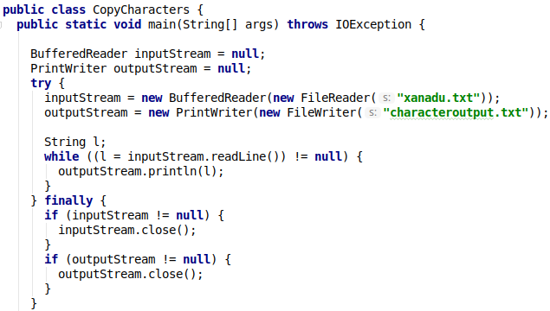
Buffered Streams
Most of the examples we've seen so far use unbuffered I/O. This means each read or write request is handled directly by the underlying OS. This can make a program much less efficient, since each such request often triggers disk access, network activity, or some other operation that is relatively expensive.
To reduce this kind of overhead, the Java platform implements buffered I/O streams. Buffered input streams read data from a memory area known as a buffer; the native input API is called only when the buffer is empty. Similarly, buffered output streams write data to a buffer, and the native output API is called only when the buffer is full.
A program can convert an unbuffered stream into a buffered stream using the wrapping idiom we've used several times now, where the unbuffered stream object is passed to the constructor for a buffered stream class. Here's how you might modify the constructor invocations in the CopyCharacters example to use buffered I/O:

There are four buffered stream classes used to wrap unbuffered streams:
- BufferedInputStream and BufferedOutputStream create buffered byte streams,
- while BufferedReader and BufferedWriter create buffered character streams.
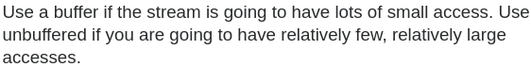

In general, buffered I/O is faster but can be less reliable under certain circumstances.
Unbuffered I/O involves reading or writing data one element at a time: If the data stream is character-based, like a file on disk in a UNIX system, that means reading or writing the data character-by-character. Because the overhead involved in each I/O request is so great (due to the physical nature of the underlying device) and the number of requests is so high, this tends to be very slow. However, because all data accesses are resolved by the I/O device immediately, there's normally no way for the data "seen" by the process to ever disagree with the data actually in storage.
Buffered I/O involves reading or writing data in chunks: If a request to read a single character is made the system will actually read, say, a thousand characters from the device into a buffer in memory, then return just the first character from the buffer to the calling routine. Subsequent requests can be fulfilled entirely from the buffer (until it is depleted), which as it exists in memory can be accessed many times faster than can the device itself.
Buffered writes happen in a similar manner: Data written by a process is first accumulated in a buffer in memory until the buffer is full (or a time limit elapses), at which point the entire buffer is written to the device at once. Again, this reduces the number of real I/O operations involved and makes the system appear much faster.
Note that some devices lend themselves to buffered I/O naturally. This is true for instance of mechanical hard drives, which not only suffer from extremely high latency compared to regular memory but also permit data to be accessed only in multi-kilobyte chunks anyway.
So is it always better to use buffered I/O? Not necessarily. Buffered reads can yield incorrect results if the data in the buffer is stale, as can happen when one process modifies the data on the storage device but another continues to work with its (now out-of-date) copy in memory. Also, buffering writes can result in data loss, if for instance power to the computer is interrupted between data being written to the buffer in memory and the buffer's contents being output (flushed) to the device. Techniques are available to address both these scenarios.
Flushing Buffered Streams
It often makes sense to write out a buffer at critical points, without waiting for it to fill. This is known as flushing the buffer.
Some buffered output classes support autoflush, specified by an optional constructor argument. When autoflush is enabled, certain key events cause the buffer to be flushed. For example, an autoflush PrintWriter object flushes the buffer on every invocation of println or format. See Formatting for more on these methods.
To flush a stream manually, invoke its flush method. The flush method is valid on any output stream, but has no effect unless the stream is buffered.

Scanning and Formatting
Programming I/O often involves translating to and from the neatly formatted data humans like to work with. To assist you with these chores, the Java platform provides two APIs. The scanner API breaks input into individual tokens associated with bits of data. The formatting API assembles data into nicely formatted, human-readable form.
Scanning
Objects of type Scanner are useful for breaking down formatted input into tokens and translating individual tokens according to their data type.
Breaking Input into Tokens
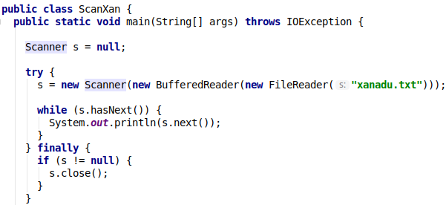
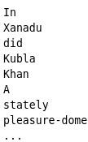
By default, a scanner uses white space to separate tokens. (White space characters include blanks, tabs, and line terminators. For the full list, refer to the documentation for Character.isWhitespace.) To see how scanning works, let's look at ScanXan, a program that reads the individual words in xanadu.txt and prints them out, one per line.

Notice that ScanXan invokes Scanner's close method when it is done with the scanner object. Even though a scanner is not a stream, you need to close it to indicate that you're done with its underlying stream.
To use a different token separator, invoke useDelimiter(), specifying a regular expression. For example, suppose you wanted the token separator to be a comma, optionally followed by white space. You would invoke

Translating Individual Tokens
The ScanXan example treats all input tokens as simple String values. Scanner also supports tokens for all of the Java language's primitive types (except for char), as well as BigInteger and BigDecimal. Also, numeric values can use thousands separators. Thus, in a US locale, Scanner correctly reads the string "32,767" as representing an integer value.
We have to mention the locale, because thousands separators and decimal symbols are locale specific. So, the following example would not work correctly in all locales if we didn't specify that the scanner should use the US locale. That's not something you usually have to worry about, because your input data usually comes from sources that use the same locale as you do. But this example is part of the Java Tutorial and gets distributed all over the world.
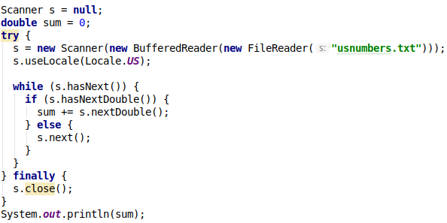
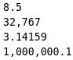
The output string is "1032778.74159". The period will be a different character in some locales, because System.out is a PrintStream object, and that class doesn't provide a way to override the default locale. We could override the locale for the whole program — or we could just use formatting, as described in the next topic, Formatting.

Formatting
Stream objects that implement formatting are instances of either PrintWriter, a character stream class, or PrintStream, a byte stream class.
Note: The only PrintStream objects you are likely to need are System.out and System.err. (See I/O from the Command Line for more on these objects.) When you need to create a formatted output stream, instantiate PrintWriter, not PrintStream.
Like all byte and character stream objects, instances of PrintStream and PrintWriter implement a standard set of write methods for simple byte and character output. In addition, both PrintStream and PrintWriter implement the same set of methods for converting internal data into formatted output. Two levels of formatting are provided:
- print and println format individual values in a standard way.
- format formats almost any number of values based on a format string, with many options for precise formatting.
The print and println Methods
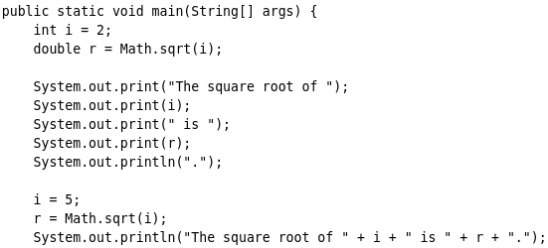
Invoking print or println outputs a single value after converting the value using the appropriate toString method. We can see this in the Root example:
The i and r variables are formatted twice: the first time using code in an overload of print (i yi alan fonksiyon onu stringe çeviriyor), the second time by conversion code automatically generated by the Java compiler ( string + int == string + string), which also utilizes toString. You can format any value this way, but you don't have much control over the results.

The format Method
The format method formats multiple arguments based on a format string. The format string consists of static text embedded with format specifiers; except for the format specifiers, the format string is output unchanged.
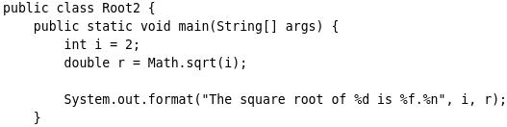
Format strings support many features. In this tutorial, we'll just cover some basics. For a complete description, see format string syntax in the API specification.
The Root2 example formats two values with a single format invocation.
Here is the output: The square root of 2 is 1.414214.
Like the three used in this example, all format specifiers begin with a % and end with a 1- or 2-character conversion that specifies the kind of formatted output being generated. The three conversions used here are:
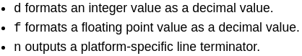
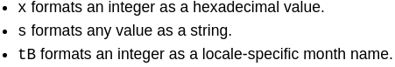
I/O from the Command Line
A program is often run from the command line and interacts with the user in the command line environment. The Java platform supports this kind of interaction in two ways: through the Standard Streams and through the Console.

Standard Streams
A more advanced alternative to the Standard Streams is the Console. This is a single, predefined object of type Console that has most of the features provided by the Standard Streams, and others besides. The Console is particularly useful for secure password entry. The Console object also provides input and output streams that are true character streams, through its reader and writer methods.
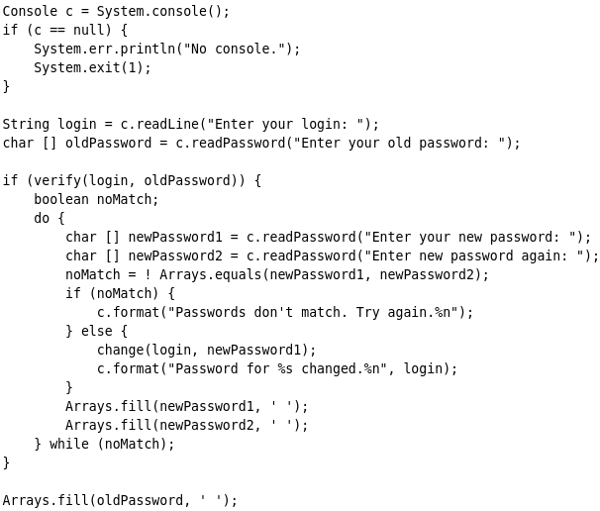
Before a program can use the Console, it must attempt to retrieve the Console object by invoking System.console(). If the Console object is available, this method returns it. If System.console returns NULL, then Console operations are not permitted, either because the OS doesn't support them or because the program was launched in a noninteractive environment.
The Console object supports secure password entry through its readPassword method. This method helps secure password entry in two ways. First, it suppresses echoing, so the password is not visible on the user's screen. Second, readPassword returns a character array, not a String, so the password can be overwritten, removing it from memory as soon as it is no longer needed.

Data Streams
Data streams support binary I/O of primitive data type values (boolean, char, byte, short, int, long, float, and double) as well as String values. All data streams implement either the DataInput interface or the DataOutput interface. This section focuses on the most widely-used implementations of these interfaces, DataInputStream and DataOutputStream.
The DataStreams example demonstrates data streams by writing out a set of data records, and then reading them in again. Each record consists of three values related to an item on an invoice, as shown in the following table:
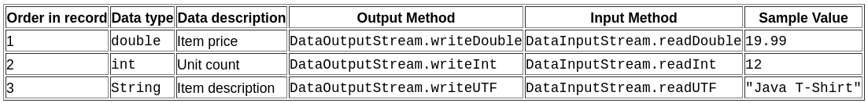
Let's examine crucial code in DataStreams. First, the program defines some constants containing the name of the data file and the data that will be written to it:
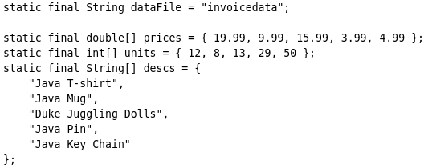
Then DataStreams opens an output stream. Since a DataOutputStream can only be created as a wrapper for an existing byte stream object, DataStreams provides a buffered file output byte stream.

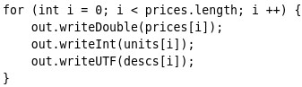
DataStreams writes out the records and closes the output stream.
The writeUTF method writes out String values in a modified form of UTF-8. This is a variable-width character encoding that only needs a single byte for common Western characters.
Now DataStreams reads the data back in again. First it must provide an input stream, and variables to hold the input data. Like DataOutputStream, DataInputStream must be constructed as a wrapper for a byte stream.
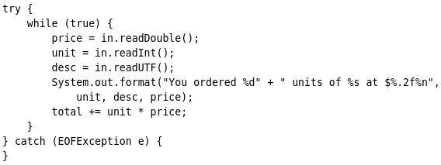
Now DataStreams can read each record in the stream, reporting on the data it encounters.

Notice that DataStreams detects an end-of-file condition by catching EOFException, instead of testing for an invalid return value. All implementations of DataInput methods use EOFException instead of return values.
Also notice that each specialized write in DataStreams is exactly matched by the corresponding specialized read. It is up to the programmer to make sure that output types and input types are matched in this way: The input stream consists of simple binary data, with nothing to indicate the type of individual values, or where they begin in the stream.
DataStreams uses one very bad programming technique: it uses floating point numbers to represent monetary values. In general, floating point is bad for precise values. It's particularly bad for decimal fractions, because common values (such as 0.1) do not have a binary representation.
The correct type to use for currency values is java.math.BigDecimal. Unfortunately, BigDecimal is an object type, so it won't work with data streams. However, BigDecimal will work with object streams, which are covered in the next section.
Object Streams
asd

